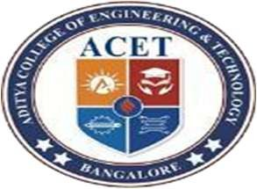
ADITYA COLLEGE OF ENGINEERING & TECHNOLOGY
2/2 KAMAKSHIPURA, HESARGHATTA HOBLI YELAHANKA, BANGALORE NORTH
BPLCK205C JAVA - QUESTION BANK
Module 4
Sl.No | Questions | RBTL
1. | Demonstrate the working of final class and final method in JAVA. | L3
2. | - What is abstract class ? Explain with example. | L2
3. | Give example for method overriding | L2
4. | - Demonstrate dynamic dispatch using abstract class in JAVA | L3

Module 5
Sl.No | Questions | RBTL
1. | What is a package ? Explain with example. | L2
2. | Demonstrate the working of interface in JAVA. | L2
3. | Explain different access modifiers using package in JAVA | L3
4. | What is an exception ? Give an example | L2
5. | Explain the procedure of creating our own exception. | L2
6. | Explain different mechanism of handling the exceptions in JAVA | L3
7. | Demonstrate the working of interface in JAVA with example | L3
8. | Write a Java program to read two integers a and b. Compute a/b and print when b is not zero. Raise an exception when b is equal to zero. Demonstrate working of array index out of Bound Exception | L4

